Asimov Young Witches and Warlocks, Harper & Row 1987 Stated First Edition, First Print, Full print line. As new dust jacket price $11.95. As new hard cover with all 207 pages tightly bound and no marks of any kind. 8vo Jacket art Deborah Healy. ISBN 0060201835

ID 000346 Price $20 Box 7
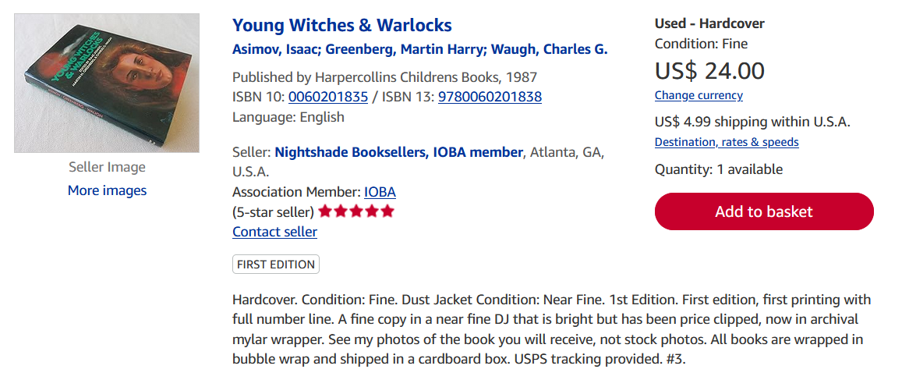
AbeBooks

